Title: Study Resources Sharing platform
Section: 5C1
Group no. 2

No. | Student Name | Student Number
1 | دينا إبراهيم الجريوي | 445008759
2 | لمى نبيل الزبيدي | 445008832
3 | لبنى منصور أباالخيل | 445008791
4 | غدي الحمدان | 445008819
5 | فجر محمد العنزي | 445008685

First Semester 2025

Contents
System descriptions 2
The development Process model used 2
Requirements: 2
Functional Requirements 2
Non-Functional Requirements 3
Context Diagram: 5
Use Case Diagram with Discretion: 5
Use Case Scenario : 6
Use case 1 [Register account ] 6
Use case 2 [Upload resources] 6
Use case 3 [Download resources] 7
Use case 4[Rate resources] 7
Use case 5 [Manage profile] 8
Use case 6 [Manage users] 8
Use case 7 [Moderate content] 9
Class Diagram: 9
Sequence Diagram 10
Activity Diagram: 11
Activity Diagram for [Register]: 11
Activity Diagram for [Upload resource]: 12
Activity Diagram for [Download resource]: 13
Activity Diagram for [Rating resource]: 14
Activity Diagram for [Manag Users]: 15

System descriptions

Our System is a place where students come together to
make learning easier and more Cooperative. you can share your notes, summaries,
presentations, e-books, and past exams or discover resources shared by others.
Everything is organized so you can quickly find what you need for your subject or level.

The development Process model used

Our project is being developed using the Incremental Model. allows us to build the system in small, manageable increments, delivering functional parts of the platform step by step. For each increment adds new features, such as user registration, resource uploading, search functionality, or community interaction, while allowing earlier parts to be tested and refined.

Requirements:

Functional Requirements

User Requirements:

1.1 Users can create an account using email, university email, or social media accounts.
1.2Users can log in and reset passwords.

2. User Profile Management
2.1 Users can view and edit their profile.
2.2 Users can set preferences for notifications and privacy.

3. Uploading Study Materials
3.1 Users can upload study materials (notes, PDFs, images, links).
3.2 Users can organize uploaded resources into collections or folders.

4. Sharing Resources
4.1 Users can share resources or links with others.
4.2 Users can comment, rate, and bookmark resources.
4.3 Users receive notifications for interactions.

5. Searching and Retrieving Resources
5.1 Users can search and filter resources by keyword, subject, or tags.
5.2 Users can view resource details and download selected materials.

6. User Interaction
6.1 Users can interact with uploaded resources by rating and commenting.
6.2 Users can receive notifications for interactions on their resources.
6.3 Users can mute notifications temporarily or permanently.

System Requirements:

1. The system shall store all uploaded user resources in the database.
1.1 The system shall assign a unique ID to each uploaded resource.
1.2 The system shall store metadata for each resource, including title, tags, subject, uploader, and upload date.
1.3 The system shall allow updating metadata when the uploader modifies the resource details.

2. The system shall allow users to upload study materials in multiple file formats.
2.1 The system shall support uploads of PDF, DOCX, and image files.
2.2 The system shall validate file formats before upload and display an error message if an unsupported file type is selected.
2.3 The system shall store uploaded files securely in the database and ensure quick retrieval when requested.
2.4 Prevent unauthorized users from modifying or deleting resources.
2.5 The system shall allow hiding the uploader’s identity from other users , when uploading resources .

3. The system should allow the user to search and retrieve resources.
3.1 The system shall provide a search functionality that allows users to search for study materials by keyword or course name.
3.2 The search shall prioritize relevant results based on keywords in titles, tags, and content.
3.3 The system shall display the most accurate and relevant results at the top of the list.
3.4 Provide users with access to download selected resources.

4. The system shall send notification to users.
4.1 Generate notifications when a user’s resource receives a rating.
4.2 Generate notifications when a user’s resource receives a comment.
4.3 Display notifications to the user within their dashboard.
4.5 The system shall allow users to mute notifications for a selected period or permanently.

5. the system should organize resources to enable efficient searching.
5.1 The system shall automatically create a resource organization entry for each uploaded resource immediately after upload.
5.2 The system shall include all relevant metadata fields—title, tags, subject, and uploader—in the resource organization.
5.3 The system shall update the resource organization automatically whenever a resource or its metadata is modified.
5.4 The system shall use the resource organization to process keyword-based queries, returning all resources that match the query terms.

Non-Functional Requirements

System Requirements:
1. Security (External)

Goal: The platform must protect user data and prevent unauthorized access.
1.1 The system shall ensure no user data breaches within any 12-month period by encrypting all user login information, including email and password, in the database using secure encryption standards.

2. Reliability (Product)

Goal: The system should consistently operate without failure, even under unexpected conditions.

2.1 The system shall maintain continuous service with no more than 2 minutes of downtime per month.
2.2 The system shall successfully process at least 99% of all resource upload and sharing requests without failure.

3. Portability (Organizational)

Goal: The platform should be accessible and functional across different devices and operating systems to ensure all students can use it conveniently.

3.1 The system shall be accessible on all major platforms, including Windows, macOS, iOS, and Android.
3.2 The system shall maintain full functionality when accessed from web browsers on desktop and mobile devices.

4. Robustness (Product)

Goal: The platform should remain stable and maintain consistent performance even under
high user loads or stressful conditions, such as during final exam periods.

4.1 The system shall remain fully operational when accessed by up to
2000 concurrent users during peak usage times.
4.2 The system shall automatically recover from temporary service interruptions within 1 minute.

5. Performance (Product)

Goal: The platform should respond quickly and efficiently to user
actions under normal or slightly heavy loads.

5.1 95% of resource pages shall load in under 2 seconds with up to 1000 concurrent users.

6. Speed (Product)

Goal: The platform should provide fast responses and quick content loading to
ensure a smooth and efficient user experience.

6.1 The system shall return search results within 5 seconds.
6.2 The system shall load the contents of a PDF file in no more than 30 seconds.

User Requirements:

1. Usability (Product)

Goal: Users should find it easy to navigate and use the platform to upload and share resources.
1.1 At least 80% of new users shall be able to successfully upload and find a resource within 3 minutes without external help.

Context Diagram:
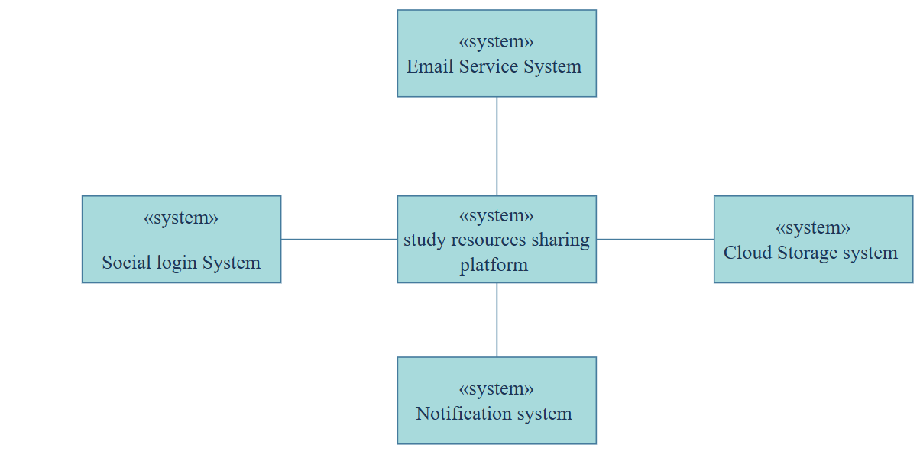

Use Case Diagram with Discretion:
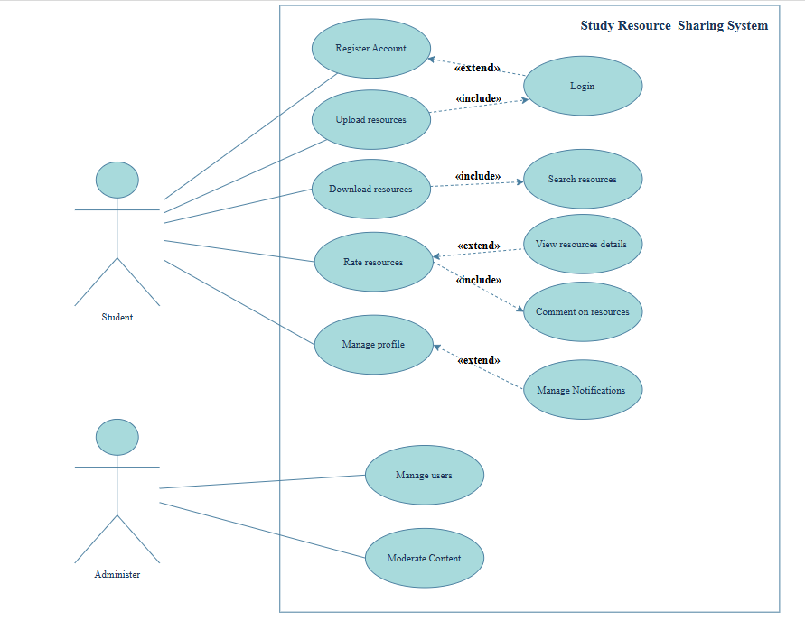
Use case diagram discretion:
The use case diagram shows the main functionalities of the Study Resource Sharing Platform with two actors: Student and Administrator. The Student can Register Account, Login, Upload resources, Download resources, Rate resources, Comment on resources, Manage Notifications, and Manage profile. Some use cases have relationships: Register extends Login, Upload includes Login (must login first), Download includes Search resources (must search first), and both Rate and Comment extend View resources details (optional actions after viewing).The Administrator can Manage users and Moderate Content to oversee the platform.

Use Case Scenario :

Use case 1 [Register account ]
Use-case Name | Register Account
Goal | Student can register an account on the study recourse sharing platform
Actors | Student
Main Success Scenario | 1 The student clicks On Register button
 | 2 The student fills in his new account information
 | 3 The student will receive activation email
 | 4 The student clicks on activate button
 | 5 The account is activated and ready to be used
 | 6. The student logs into the system
 | 7. The students account and information are stored in the system
Extension | 2.a Student enters an existing email, and system will display that the account already exists
 | 2.b Password is not strong enough
 | 2.c student couldn't register an account

Use case 2 [Upload resources]

Use-case Name | Upload resources
Goal | Student is allowed to upload files into the sharing platform
Actors | Student
Main Success Scenario | 1 student selects the files
 | 2 student includes details about the files (tags and titles)
 | 3 the student uploads the files into the system
 | 4 student receives a message the upload is successful
 | 5 The files are saved in the system database
Extension | 1.a file format is not supported, and system will display invalid file type
 | 2.b file size exceeds the limit
 | 3.a network connection fail during the upload and files are not uploaded
 | 5.a Files are not uploaded and not saved in the system

Use case 3 [Download resources]
Use-case Name | Download Resources
Goal | Student is allowed to download files into the sharing platform
Actors | Student
Main Success Scenario | 1 Student is logged in
 | 2 student search for the desired files
 | 3 student clicks on download files
 | 4 Files are downloaded into student device
Extension | 1.a student is not logged in
 | 2.a desired file is not found, and system will show that the resource is not available
 | 4.a files are not downloaded

Use case 4[Rate resources]
Use-case Name | Rate Recourses
Goal | Student is allowed to submit his rating and comments on recourses on the sharing platform
Actors | Student
Main Success Scenario | 1 student will select the files to rate
 | 2 student views the recourse details
 | 3 student highlights the rating stars
 | 4 the student can comment about the files
 | 5 student submits his rating
 | 6 The rating is saved in the system
 | 7 The rating is available for all students to see
Extension | 2.a Resource details are not available
 | 2.b Student can't submit rating
 | 6.a Rating is not saved in the system
 | 6.b System will display that rating submission has failed
 | 7.a Rating is not available for everyone to see

Use case 5 [Manage profile]

Use-case Name | Manage profile
Goal | Student can manage his account information and notifications
Actors | Student
Main Success Scenario | 1 student selects on manage profile
 | 2 student views his account
 | 3 student edits his account information
 | 4 student saves any changes
 | 5 The profile is updated
Extension | 3.a Invalid information entered
 | 4.a Changes are not saved
 | 5.a Update fails and system will display that it is unable to save changes

Use case 6 [Manage users]

Use-case Name | Manage users
Goal | Administer allowed to view, monitor and manage users accounts
Actors | Administer
Main Success Scenario | 1 Administer can view user’s information
 | 2 Administer can suspend and deactivate accounts
 | 3 Administer can turn on and off any system services from users
 | 4 users accounts are changed
 | 5 students who are suspended will lose access to the platform
 | 6 system services are updated
Extension | 1.a Administrator is not logged in
 | 2.a Administrator couldn't suspend or deactivate student's account
 | 4.a Users accounts are not changed
 | 2.b Administer couldn't manage system services
 | 6.a System is not updated
 | 6.b System will show a message of operation failure

Use case 7 [Moderate content]

Use-case Name | Moderate Content
Goal | Administer can moderate any content that are uploaded in the platform
Actors | Administer
Main Success Scenario | 1 Administer picks the content
 | 2 Administer reviews the reported content
 | 3 Administer decides on whether to approve the content or not
 | 4 Any inappropriate content will be removed
 | 5 System will be updated
 | 6 users will receive a notification about the moderated content
Extension | 1.a administer tries to moderate a non-existing content or already deleted one
 | 3.a administer accidentally approves an inappropriate content
 | 4.a The actual inappropriate content is not removed
 | 5.a system is not updated

Class Diagram:

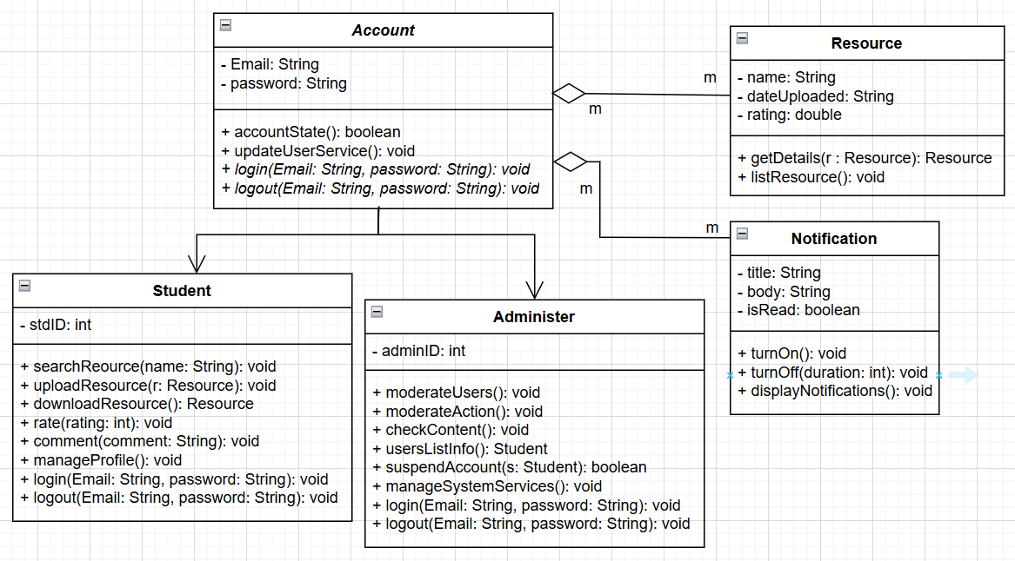
In the class diagram we have an inheritance relationship between class Account, which is an abstract class and it is this way because we do not want an object of class Account, and the two classes Student and Administer, both Student and Administer inherit the abstract method logIn() and logOut(). There is an aggregation relationship between class Account and class Resource, and it is a many to many multiplicity because an account can access many recourses, and a recourse can be accessed by many accounts. There is another aggregation relationship between class Account and class Notification, and it is a many to many multiplicity because a notification can be sent to many accounts while an account can have many notifications.

Sequence Diagram

-
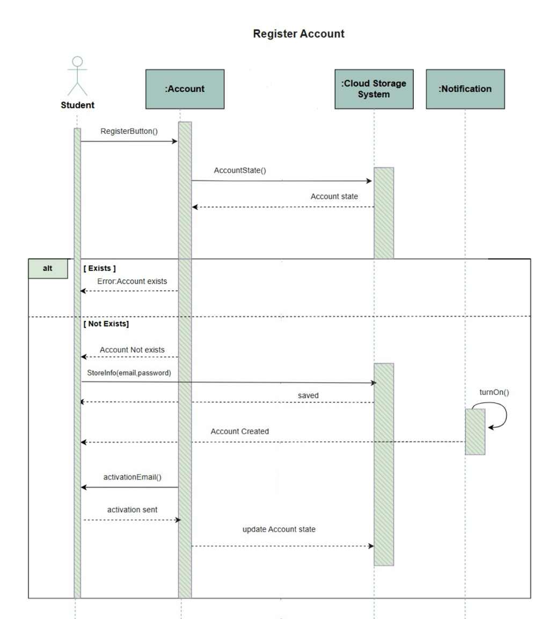

-

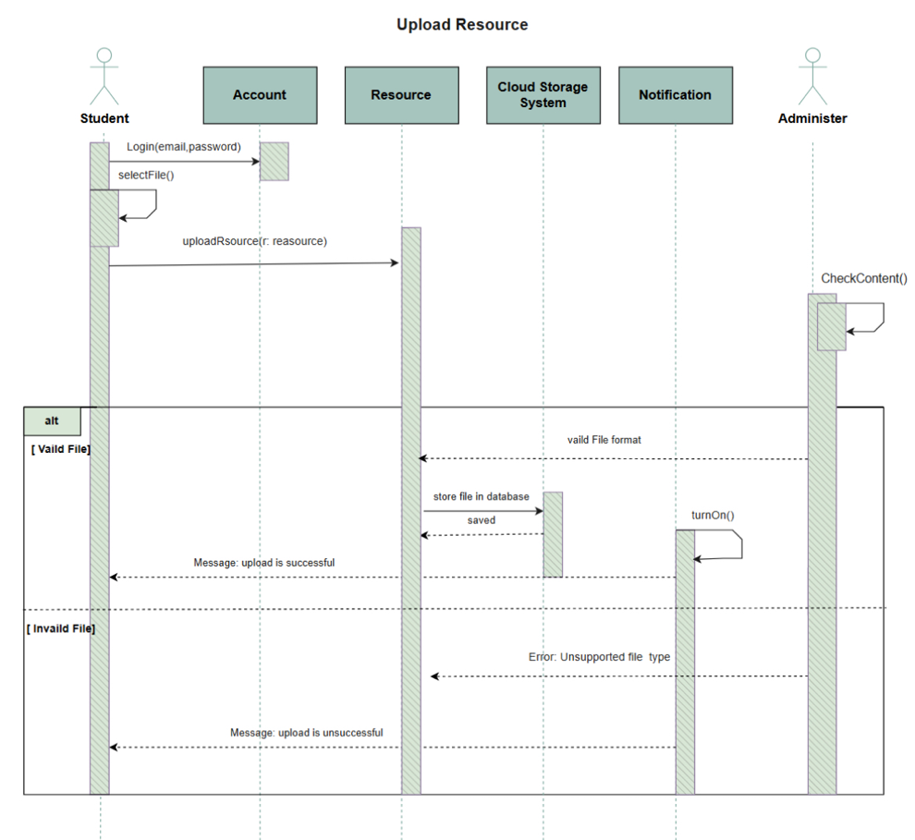
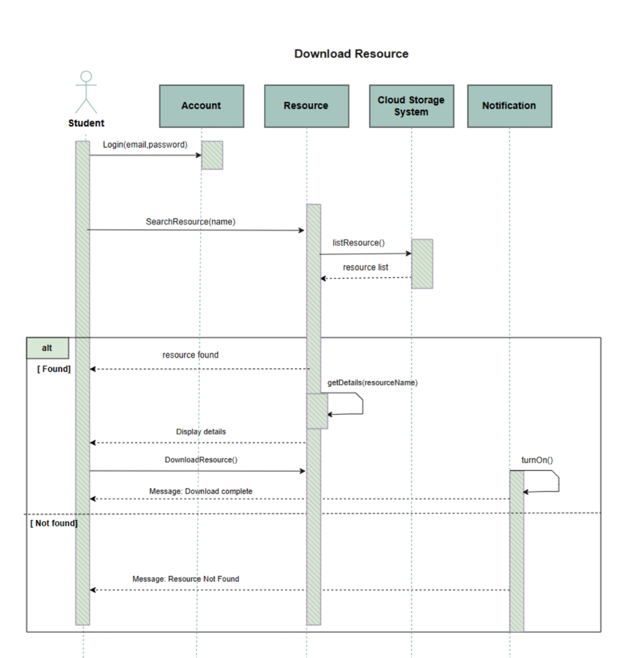
-

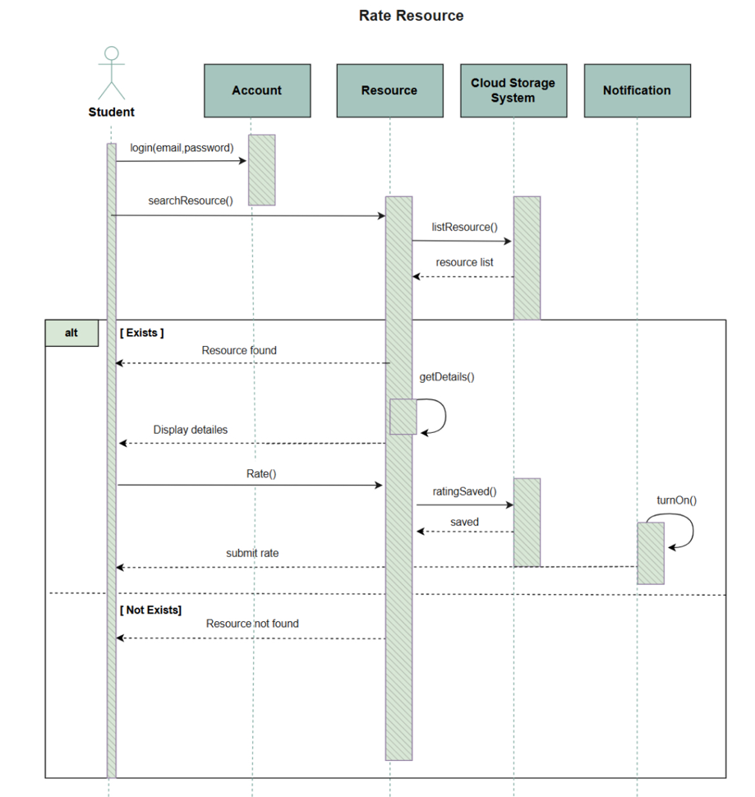
-

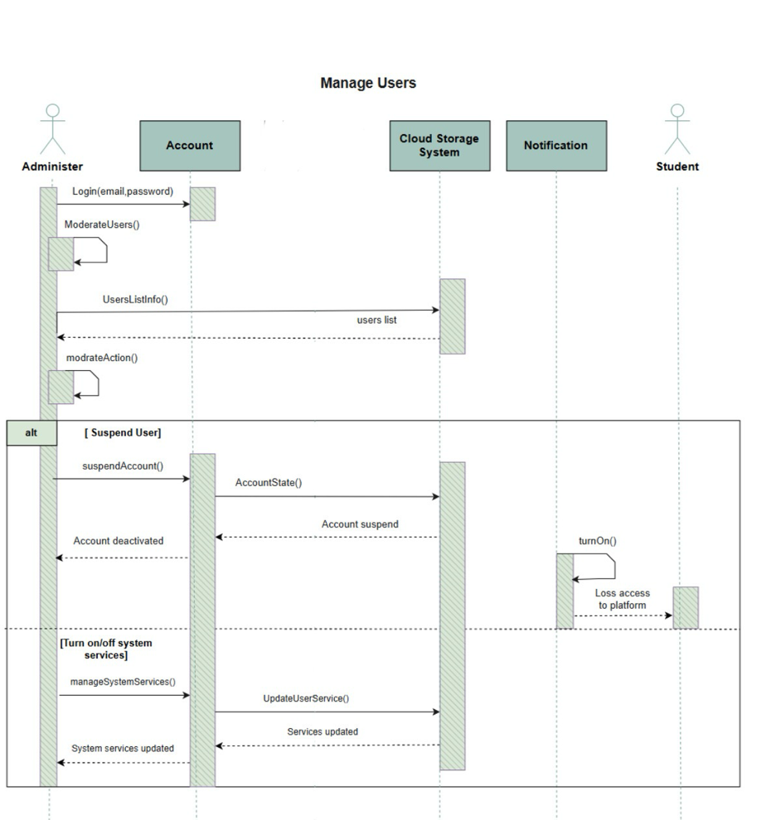
-

Activity Diagram:

Activity Diagram for [Register]:

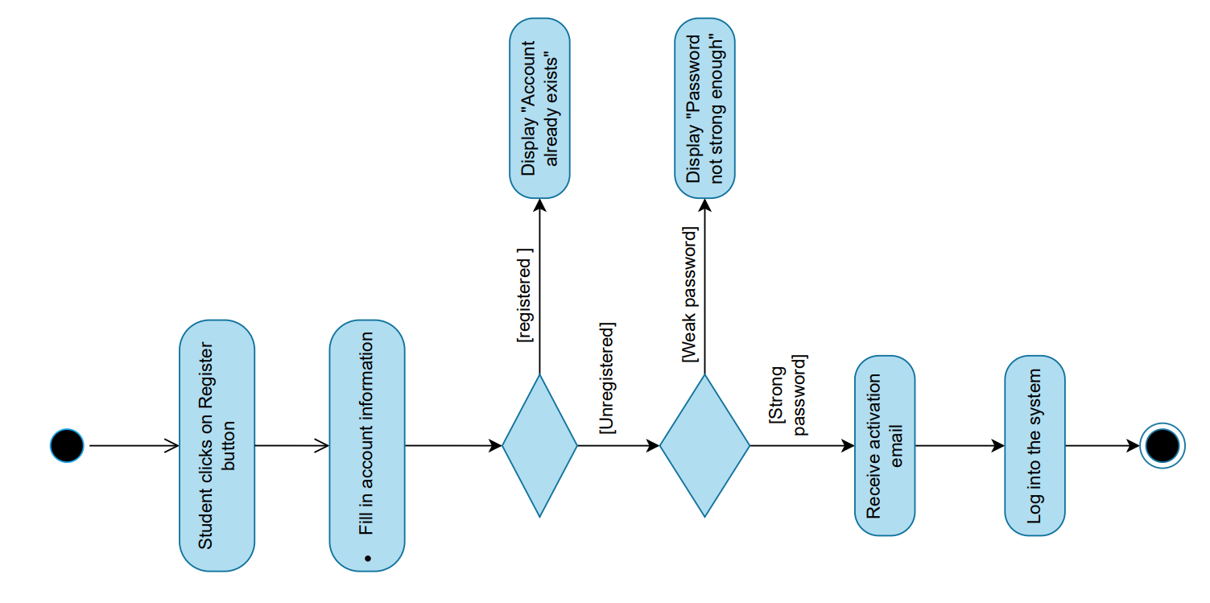

Activity Diagram for [Upload resource]:
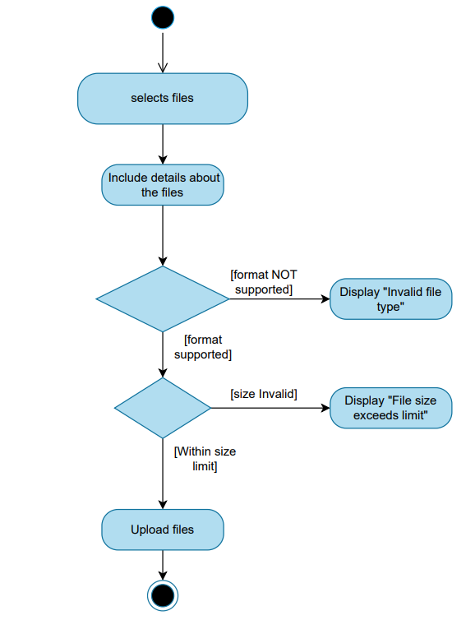

Activity Diagram for [Download resource]:
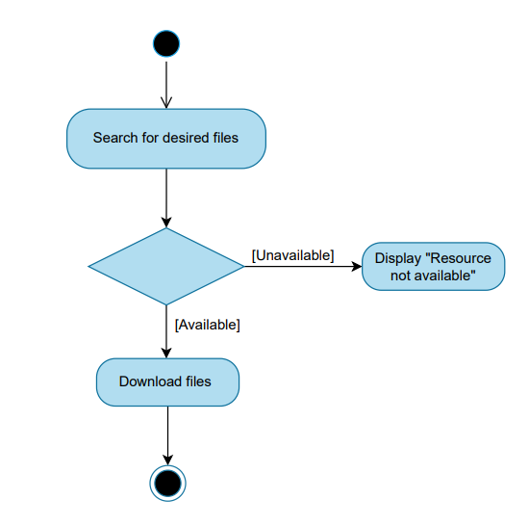

Activity Diagram for [Rating resource]:
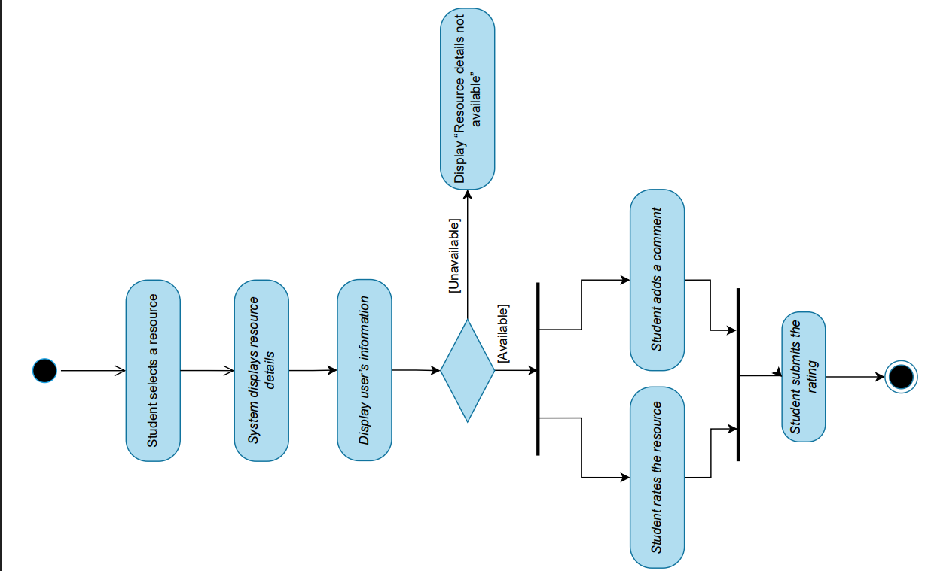

Activity Diagram for [Manag Users]:

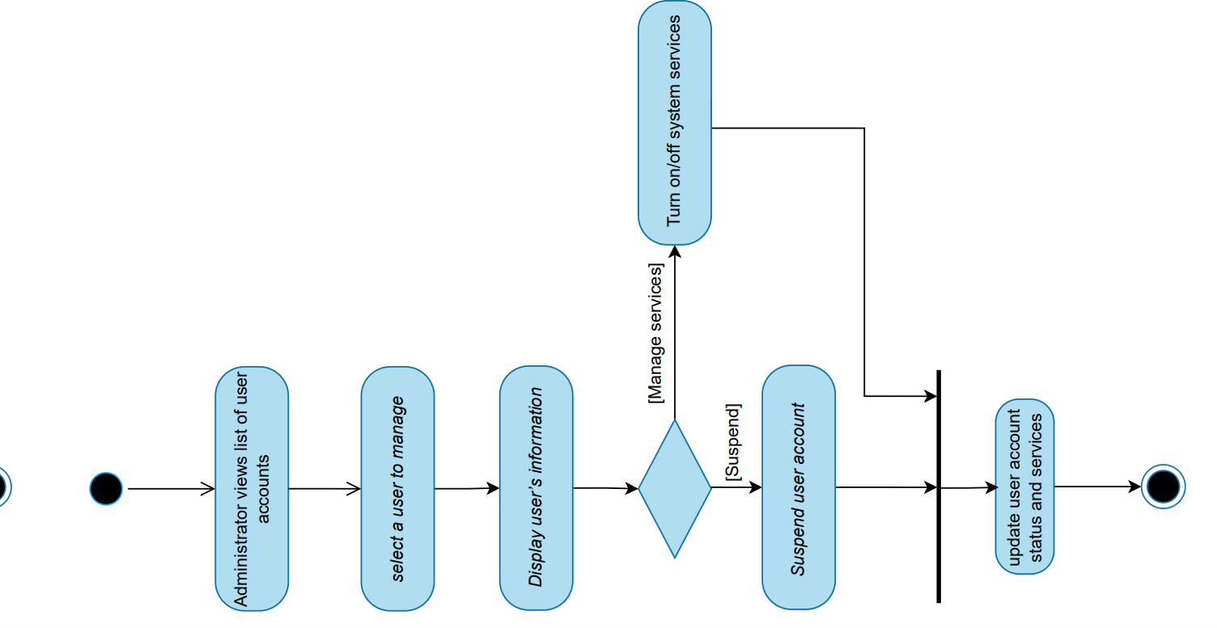

State Chart Diagrams:

System Architecture Diagram:

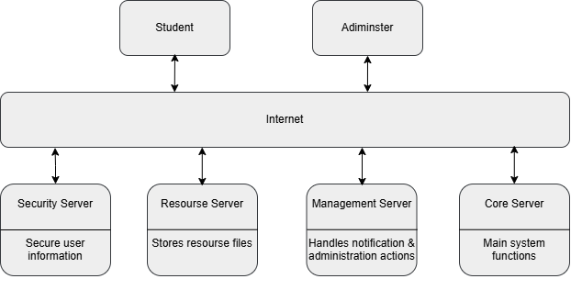

We chose the Client-Server model architecture because the Student Resource Sharing Platform is an interactive distributed web system. This system contains servers that provide specific services such as uploading, downloading and rating resources. Such model allows clients to access these servers and handles heavy user traffic, considering that many students will be accessing and using the platform at the same time. The dedicated servers also enforce strong security and maintainability which leads to better performance.

